// Importing express module

const express = require("express")

const app = express()

// Handling GET / request

app.use("/", (req, res, next) => {

res.send("This is the express server")

})

// Handling GET /hello request

app.get("/hello", (req, res, next) => {

res.send("This is the hello response");

})

// Server setup

app.listen(3000, () => {

console.log("Server is Running")

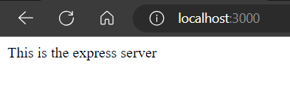})

const fs = require('fs');

const filepath = 'text.txt';

// Reads a file in a asynchronous and non-blocking way

fs.readFile(filepath, {encoding: 'utf8'}, (err, data) => {

// Prints the content of file

console.log(data);

});

// This section calculates the sum of numbers from 1 to 10

let sum = 0;

for(let i=1; i<=10; i++){

sum = sum + i;

}

// Prints the sum

console.log('Sum: ', sum);

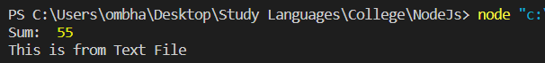

-------------------------------------------------------------------P20 Output below----------------------------------------------------------

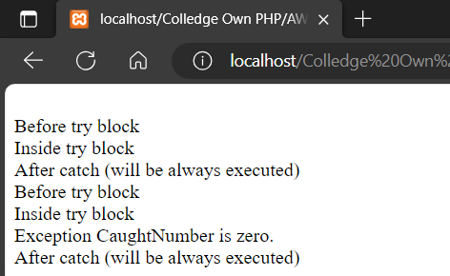

<?php

// PHP Program to illustrate normal

// try catch block code

function demo($var) {

echo "<br> Before try block";

try {

echo "<br> Inside try block";

// If var is zero then only if will be executed

if($var == 0)

{

// If var is zero then only exception is thrown

throw new Exception('Number is zero.');

// This line will never be executed

echo "<br> After throw (It will never be executed) ";

}

}

// Catch block will be executed only

// When Exception has been thrown by try block

catch(Exception $e) {

echo "<br> Exception Caught", $e->getMessage();

}

// This line will be executed whether

// Exception has been thrown or not

echo "<br> After catch (will be always executed)";

}

// Exception will not be raised

demo(5);

// Exception will be raised here

demo(0);

?>